1. **Are the HTML tags and elements the same thing?**
2. HTML tags are used to hold the HTML element.HTML element hold the content.
3. **What are tags and attributes in HTML?**
4. HTML attributes are used to describe the characteristic of an HTML element in detail.
5. **What are void elements in HTML? With Example.**
6. A void element is an element whose content model never allows it to have contents under any circumstances.

EXAMPLE:

Img , input , link , area , base , br , col etc.

1. **What are HTML Entities? With Example.**
2. An HTML entity is a piece of text (“string”) that begins with an ampersand (&) and ends with a semicolon (;).

EXAMPLE:

&copy →©

&reg→®

&curren→¤

1. **What are different types of lists in HTML? With Example.**
2. 1.Order list

2.Unorder list

3.Description list / Data list

1. Order list: 1 , A , a

2 , B , b

3 , C , c

1. Unorder list: square , circle , disk , none

(3) Description list / Data list: dt: data terms

dd: data definition - cold

dd: data definition – hot

**(6) What is the ‘class’ attribute in HTML? With Example.**

The class attribute specifies one or more classnames for an element. The class attribute is mostly used to point to a class in a style sheet**.**

EXAMPLE:

<!DOCTYPE html>

<html>

    <head>

        <style>

            .abc{

                background-color: black;

                color: white;

                padding: 8px;

            }

        </style>

    </head>

    <body>

        <h2 class="abc">CHINA</h2>

        <p> china has largest population in the world.</p>

        <h2 class="abc">INDIA </h2>

        <p> india has  second largest population in the world.</p>

    </body>

<html>

● Output:

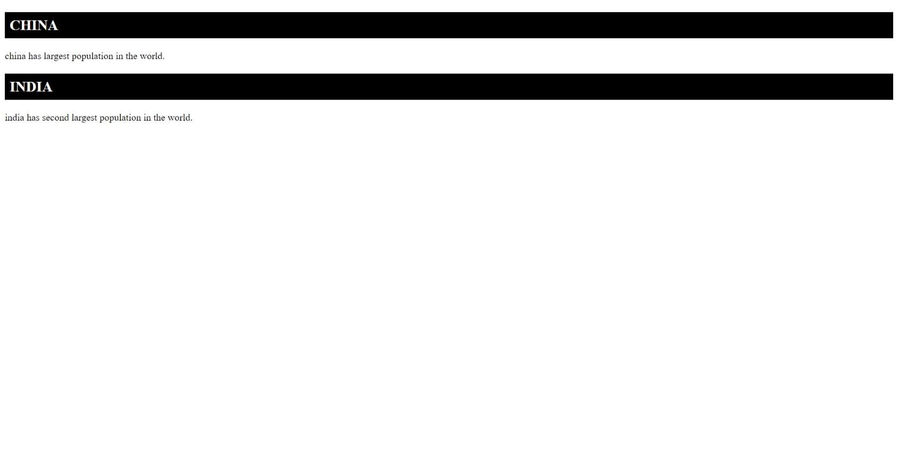

**(7) What is the difference between the ‘id’ attribute and the ‘class’ attribute of HTML elements? With Example.**

1. A Class name can be used by multiple HTML elements, while an ID name must only be used by one HTML element within the page.

EXAMPLE:

<!DOCTYPE html>

<html>

    <head>

        <style>

            #abc{

                text-align: center;

                color: blue;

                font-size: 20px;

            }

        </style>

    </head>

    <body>

        <h1>Welcome</h1>

        <p id="abc">this paragraph will be affected.</p>

        <p>this paragraph will not be affected.</p>

    </body>

</html>

●Output:

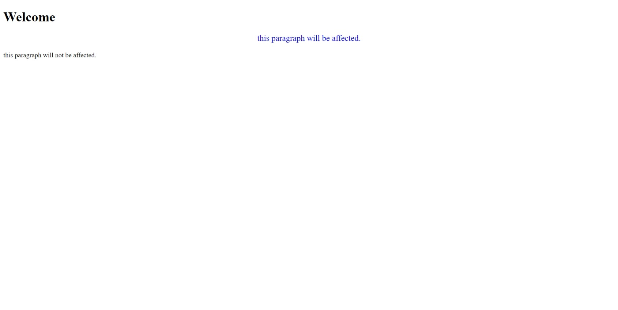

**(8)** **What are the various formatting tags in HTML?**

1. HTML provides many predefined elements that are used to change the formatting of text.

EXAMPLE:

<b> and <strong> Tags**→** make the text bold.

<i> and <em> Tags**→** make the text italic and emphasized.

<small> Tag→ set small font-size.

<big> Tag→ set big font-size.

<sup> Tag→ superscript text.

<sub> Tag→ subscript text.

<mark> Tag→ highlight a text.

**(9) How is Cell Padding different from Cell Spacing? With Example.**

1. Cellpadding basically defines the space present between a table cell’s border and the content present in it.

Cellspacing basically defines the space present between individual adjacent cells.

EXAMPLE:

<!DOCTYPE html>

<html>

 <head>

 </head>

 <body>

   <table

     border="2"

     cellpadding="25"

     cellspacing="30"

     border="solid"

   >

     <thead>

       <td><span>Name</span></td>

       <td><span>Position</span></td>

     </thead>

     <tbody>

       <tr>

         <td>LINE 1</td>

         <td>01</td>

       </tr>

       <tr>

         <td>LINE 2</td>

         <td>02</td>

       </tr>

     </tbody>

   </table>

 </body>

</html>

● Output:

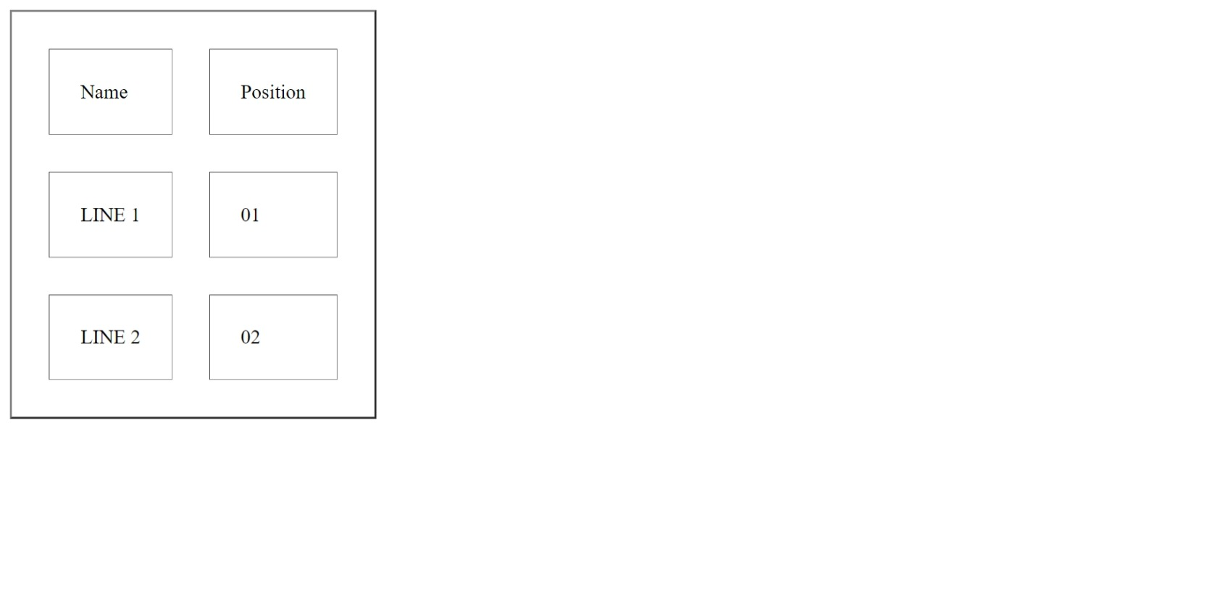

**(10) How can we club two or more rows or columns into a single row or column in an HTML table? With Example.**

**A.** The rowspan is used to merge or combine the number of cells in a row whereas the colspan is used to merge column cells in a table.

EXAMPLE:

<!DOCTYPE html>

<html>

   <head></head>

<body>

   <h2>Tables in HTML</h2>

   <table border=”1”>

      <tr>

         <th >First Name </th>

         <th>Job role</th>

      </tr>

      <tr>

         <td >Tarun</td>

         <td rowspan="2">Content writer</td>

      </tr>

      <tr>

         <td >Akshay</td>

      </tr>

      <tr>

         <td colspan="2">Welcome to the company</td>

      </tr>

   </table>

</body>

</html>

● Output:

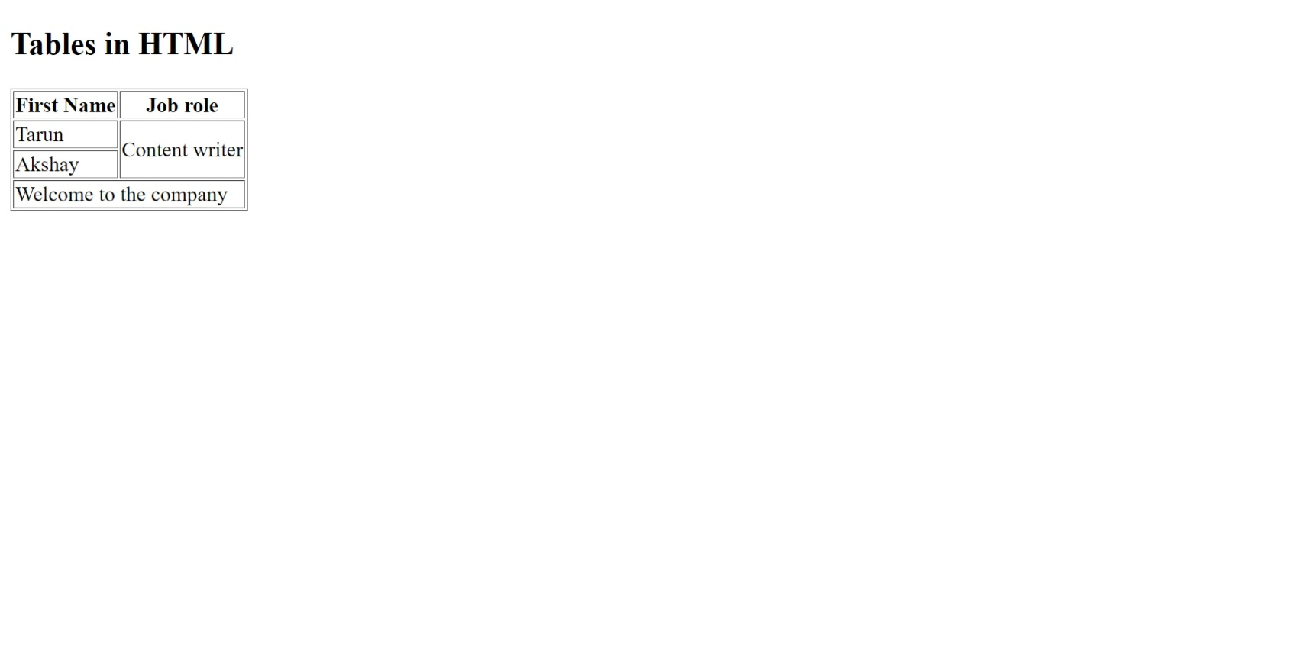

**(11) What is the difference between a block-level element and an inline element?**

**A.** Block Elements occupy the full width irrespective of their sufficiency. Inline elements occupy only sufficient width required.

Block elements always start in a line. Inline elements don’t start in a new line. Block elements have top and bottom margin. Inline elements don’t have top and bottom margin.

**(12) How to create a Hyperlink in HTML? With Example.**

**A.** ● Use the <a> element to define a link.

● Use the href attribute to define the link address

● Use the target attribute to define where to open the linked

Document

● Use the <img> element (inside <a> to use an image as a link

● Use the malito: scheme inside the href attribute to create a link that

Opens the user’s email program

EXAMPLE:

<a href="default.asp">

    <img src="smiley.gif" alt="HTML tutorial">

  </a>

●Output:



**(13) What is the use of an iframe tag? With Example.**

**A.** An inline frame (iframe) is a HTML element that loads another HTML page within the document. It essentially puts another webpage within the parent page. They are commonly used for advertisements , embedded videos , web analytics and interctive content.

EXAMPLE:

<iframe src="https://www.yutube.com" title="youtube Free Online Web Tutorials"></iframe>

●Output:



**(14) What is the use of a span tag? Explain with example?**

**A.**  The span tag is used for the grouping of inline elements & this tag does not make any visual change by itself.

EXAMPLE:

<p>My mother has <span style="color:blue">blue</span> eyes.</p>

**●Output:**



**(15) How to insert a picture into a background image of a web page? With Example.**

**A.** To set the background image of a webpage, use the CSS style. Under the CSS <style> tag, add the property background-image. The property sets a graphic such as jpg, png, svg, gif, etc.

EXAMPLE:

<!DOCTYPE html>

<html>

    <head>

        <style>

            body{

                background-image: url("C:\Users\makavana tushar\Pictures\Saved Pictures\abc.png");

            }

        </style>

    </head>

    <body>

        <h1>welcome</h1>

    </body>

</html>

●Output:



**(16) How are active links different from normal links?**

**A.** By default, a link will appear like this (in all browsers):

→An unvisited link is underlined and blue

→A visited link is underlined and purple

→An active link is underlined and red

**(17) What are the different tags to separate sections of text?**

**A.** The <br> tag is one way to separate the lines of text. There are other tags like the <p> tag and <blockquote> tag that are also used to separate sections of text.

● Create below example using only HTML tags without CSS.

<!DOCTYPE html>

<html lang="en">

<head>

    <meta charset="UTF-8">

    <meta name="viewport" content="width=device-width, initial-scale=1.0">

    <title>Document</title>

</head>

<body>

    <table border="1" align="center">

        <tr align="center">

            <td rowspan="2"><a href="link">Home</a></td>

            <td rowspan="2"><a href="link">about</a></td>

            <td rowspan="2"><a href="link">contact</a></td>

            <td rowspan="2"><a href="link">help</a></td>

            <td rowspan="2"><a href="link">store</a></td>

            <td bgcolor="#FF0000"><a href="link" >download</a></td>

        </tr>

        <tr>

            <td align="center" bgcolor="#FF0000">app</td>

        </tr>

        <tr>

            <td colspan="6">

                <img src="C:\Users\makavana tushar\Pictures\Saved Pictures\abc.png" alt="no img" height="300" width="100%">

            </td>

        </tr>

        <tr>

            <td colspan="6" bgcolor="#ff0000" align="center">contact-us-page</td>

        </tr>

        <tr>

            <td colspan="6"><img src="C:\Users\makavana tushar\Pictures\Saved Pictures\photo.png" alt="no img" height="150" width="100%"></td>

        </tr>

        <tr>

            <td colspan="3" align="center" bgcolor="#00FFFF">first-name<input type="text" placeholder="Enter your name"></td>

            <td colspan="3" align="center" bgcolor="#00FFFF">last-name<input type="text" placeholder="Enter your name"></td>

        </tr>

        <tr>

            <td colspan="3" align="center" bgcolor="#00FFFF">Email-d<input type="text" placeholder="Enter your email id"></td>

            <td colspan="3" align="center" bgcolor="#00FFFF">phone-no.<input type="text" placeholder="Enter your phone no."></td>

        </tr>

        <tr>

            <td colspan="3" align="center" bgcolor="#00FFFF">city

                <select>

                    <option>Ahmedabad</option>

                    <option>Bhavnagar</option>

                    <option>Jamnagar</option>

                    <option>Rajkot</option>

                    <option>Surat</option>

                </select>

            </td>

            <td colspan="3" align="center" bgcolor="#00FFFF">Gender:

                <label>MALE</label>

                <input type="radio" name="abc" id="xyz">

                <label>FEMALE</label>

                <input type="radio" name="abc" id="xyz">

                <label>OTHER</label>

                <input type="radio" name="abc" id="xyz">

            </td>

        </tr>

        <tr>

            <td colspan="3">

                <map name="tops technology"><div>

                    <iframe width="270" height="250" frameborder="0" src="https://www.bing.com/maps/embed?h=250&w=270&cp=23.004737579496492~72.59662628173828&lvl=15&typ=d&sty=r&src=SHELL&FORM=MBEDV8" scrolling="no">

                    </iframe>

                    <div style="white-space: nowrap; text-align: center; width: 270px; padding: 6px 0;">

                       <a id="largeMapLink" target="_blank" href="https://www.bing.com/maps?cp=23.004737579496492~72.59662628173828&amp;sty=r&amp;lvl=15&amp;FORM=MBEDLD">View Larger Map</a> &nbsp; | &nbsp;

                       <a id="dirMapLink" target="_blank" href="https://www.bing.com/maps/directions?cp=23.004737579496492~72.59662628173828&amp;sty=r&amp;lvl=15&amp;rtp=~pos.23.004737579496492_72.59662628173828____&amp;FORM=MBEDLD">Get Directions</a>

                   </div>

               </div></map>

            </td>

            <td colspan="3">

                <iframe width="560" height="315" src="https://www.youtube.com/embed/zdiNTyR_2ps" title="YouTube video player" frameborder="0" allow="accelerometer; autoplay; clipboard-write; encrypted-media; gyroscope; picture-in-picture; web-share"></iframe>

            </td>

        </tr>

    </table>

</body>

</html>

● Output:

